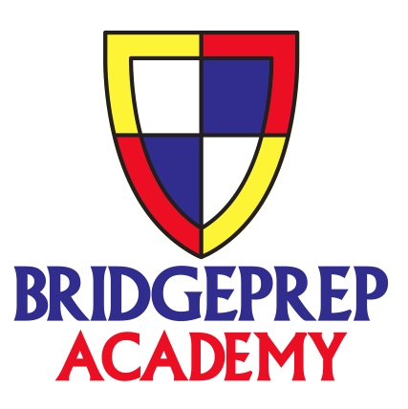**BridgePrep Academy of Village Green**

**Class Trips**

3rd Grade Legoland April 26, 2019

4th Grade Animal Kingdom April 26, 2019

5th Grade Magic Kingdom April 18, 2019

6th Grade Sea World April 18, 2019

7th Grade April 18, 2019

8th Grade Gradventure May 10, 2019 (No Parents allowed as per Park)

**Price:** $160.00

**Price Includes:**

Shirt

Transportation to and from the Park

Park Admission

**Payment Plan: 1st Payment $40.00 October 1, 2018**

**2nd Payment $ 40.00 November 1, 2018**

**3rd Payment $ 40.00 December 3, 2018**

**Final Payment $40.00 January 8, 2019**

Student Name: ___________________________________________________

Class Trip: _______________________________________________________

Homeroom Teacher: ______________________________________________

Amount Paid: ____________________________________________________

Shirt Size: _______________________________________________________

* Please make sure your payment is received by October 1st to reserve your seat on the bus.